Biological robustness is a property of biological systems to maintain their structural and functional stability when disturbed by uncertain factors such as external perturbations or internal parameter perturbations. Biological robustness is ubiquitous and exists throughout the whole biological system, organs, cells, molecules and other levels. In addition, Robustness is considered to be a universal property of biological systems and a fundamental feature of complex evolutionary systems. It is achieved through several basic principles that are common to both biological organisms and complex engineered systems.Robustness is good for evolution, and robustness features are often chosen by evolution.The specific architectural features observed in stable systems make such a reciprocal process possible.But there are trade-offs between robustness, fragility, performance, and resource requirements that account for system behavior, including failure patterns.

System feedback is the most important realization mechanism of biological robustness. Biological systems use the control mechanism of positive and negative feedback to ensure the robustness of the system. At the same time, a closed feedback system is formed in a biological system, and multiple reactions are carried out together to form a biological network. In my understanding, biological fragility refers to the factors that are easily affected or disturbed in the biological system, the reactions or pathways that may be damaged or mutated, leading to the loss of biological robustness of the system, thus becoming vulnerable and unable to continue to maintain the characteristics of the steady state. Mathematical modeling is an important method for the study of biological robustness.The understanding of biological robustness is of great significance for the occurrence, development and treatment of cancer,MDS, diabetes and other diseases. Insight into the inherent properties of robust systems will provide guiding principles for better understanding of complex diseases and treatment design.

Bacterial chemotaxis clearly demonstrates biological robustness in physiological phenomena. For example, chemotaxis ligands in *E. coli* bind to a specific receptor McP to form a stable complex of proteins CheA and Chcw. CheA is a phosphorylating regulator enzyme, and CheY binds to flagellar motor and produces movement. The frequency of the ligand bound to the receptor is modified by the kinase of CheA, and the receptor is also reversibly methylated. Methylation drives enzyme activation and ADAPTS to ligand concentration changes[1].The two proteins in the adaptive process, one is CheR methylation, the other is CheB demethylation, CheA indirect CheB phosphorylation feedback mechanism to promote demethylation, showed in **Fig. 1**.This feedback mechanism that is able to adapt to changes in ligand concentration embodies biological robustness.

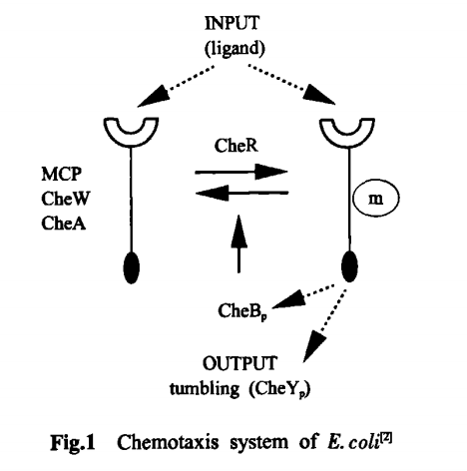

Biological fragility is currently being widely studied as a new treatment for cancer. Examples of biological fragility include: This prospect presents locus of fragility in signaling complex system network, controlling the cell cycle progression through the PI3K/AKT/mTOR/RAN pathway and cell migration and angiogenesis through the VEGF/PI3K/AKT/NO/ICAM-1 pathway. The locus of fragility of these pathways is AKT, which is regulated by a balance of catalase/H2O2 or by AKT inhibitor. Tiny and trivial perturbations such as regulating robust signaling molecule AKT, abolishing its phosporilation and inducing cascading failure of robust signaling pathways for cell growth, proliferation, migration, and angiogenesis[3]. An anticancer effect of the antioxidant is achieved through the fraility of this netwrokis: AKT locus, by abolishing signals from growth factors VEGF, HGF, HIF-1alpha and H2O2.

Biological robustness is a characteristic of the ability to express the ability to maintain a stable state. If there is no such a characteristic, then from the biological level, whether it is a microbe, a cell or an organism's survival will not be able to bear any degree of change and disturbance, and can only live in a completely static world, which is obviously impossible.Therefore, no matter for any organism, it is necessary to have biological robustness to adapt to the changing factors in the environment. Fragility may cause biological systems to collapse, block, etc., leading to the disruption of biological networks. Aiming at biological fragility, we can build molecular networks to predict the sites that reflect fragility, such as gene regulatory network, protein interaction network, and metabolic network.The establishment of molecular network model can be used to build a theoretical framework for the robustness and fragility of system analysis, and can be used to analyze the fragility sites to avoid the loss of robustness caused by the influence of sites.

All in all, robustness and fragility of biological networks are correlated with each other, and fragility can be considered as an unexecpted mutation at the nodes og the robustness network. Studying about robustness and fragility provides us with a new insight into the topological characteristics versus their functional importance in biomolecular regulatory networks[4].

**Reference：**

1. Bing Z , Jiali B , Lei Y , etal. Progress of biological robustness [J]. *Journal of biophysics*, 2007, 23(5):357-363.

[2]ShanShan Y, Li M, Boxin S,etal. Advances in chemotaxis of bacteria [J]. *Chinese Agricultural Science Bulletin*, 2015, 31(6):7.

[3]Radisavljevic Z. AKT as locus of fragility in robust cancer system [J]. *Cell Biochem*. 2008 Aug 15;104(6):2071-7.

[4]Kwon YK, Cho KH. Quantitative analysis of robustness and fragility in biological networks based on feedback dynamics [J]. *Bioinformatics*. 2008 Apr 1;24(7):987-94.